Layout of Program, Library Function Calls and error handling

LAB # 02



Fall 2022

CSE302L System Programming Lab

Submitted by:

**Maaz Habib**

Registration No. :**20PWCSE1952** Class Section: **C**

“On my honor, as student of University of Engineering and Technology, I have neither given nor received unauthorized assistance on this academic work.”

Student Signature:

Submitted to:

Engr. Abdullah Hamid

Sunday, October 23nd, 2022

# Department of Computer Systems Engineering University of Engineering and Technology, Peshawar

**Lab Objective(s):**

* Understand and implement Error Handling.
* Understand the difference between Initialized and Uninitialized static variables.

# Task # 01:

Write two C programs for the analysis of the difference in executable file sizes while using:

1. **Uninitialized Static Variables**
2. **Initialized Static Variables**

Use ls -l to compare the sizes of the executable modules for the above two C programs.

# Code:

Initialized Static Variables:

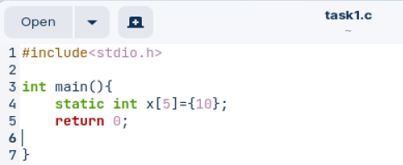

Uninitialized Static Variables:

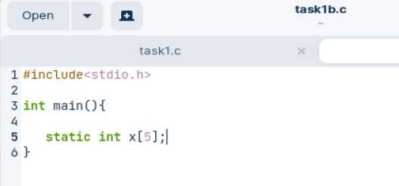

**Output / Graphs / Plots / Results:**

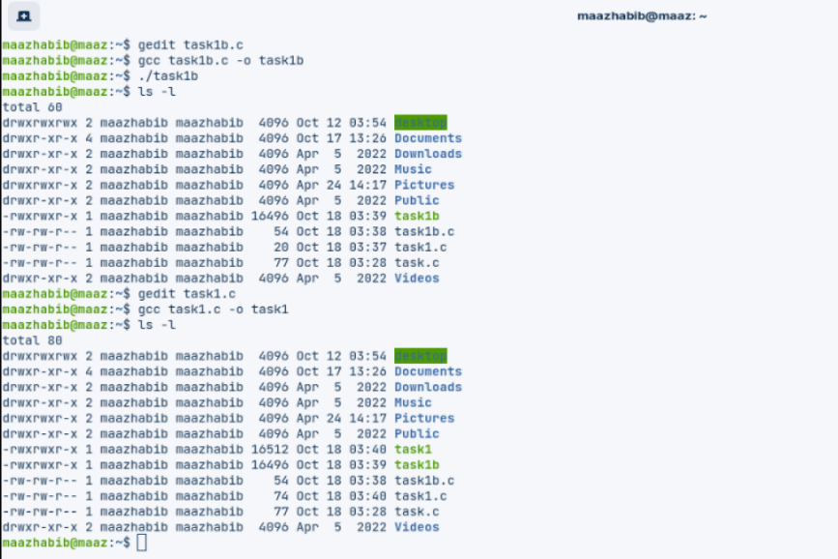

# Task # 02:

Analyze the return values and error numbers/error stings of wait system call on:

1. **Success**
2. **Failure Using:**
3. **Strerror**
4. **Perror Success:**

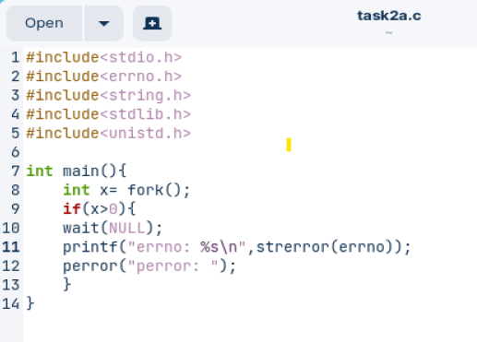

**Output:**

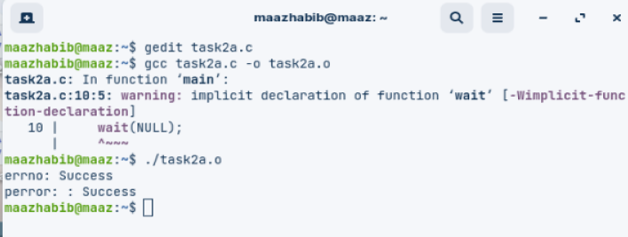

# Failure:

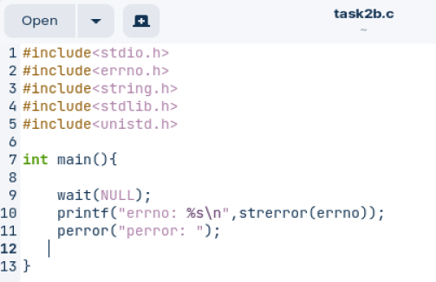

Output:

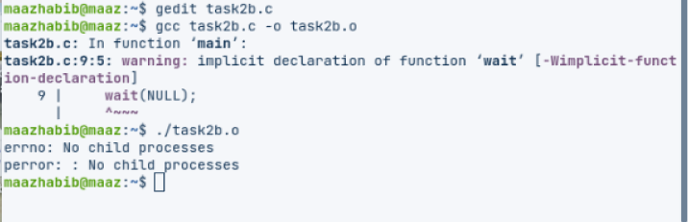

# Task 3:

Analyze the return values and error numbers/error stings of close system call on:

1. **Success**
2. **Failure Using:**
3. **Strerror**
4. **Perror**

**Success:**

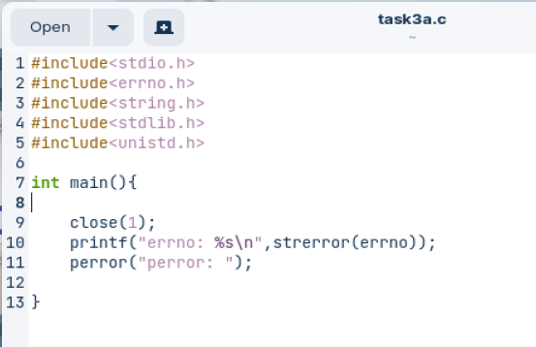

Output:

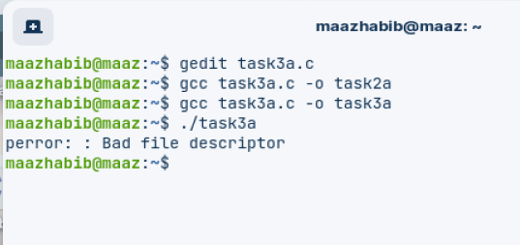

# Failure:

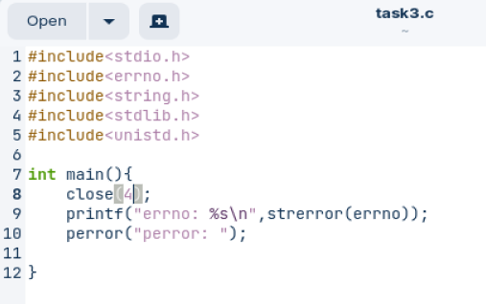

Output:

